
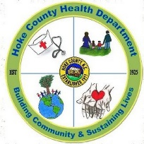
Hoke County Health Department
683 East Palmer Road
Raeford, NC 28376

Helene Edwards, DrPH, MS, RD, LDN Office (910) 875-3717
Health Director FAX (910) 875-6351

Job Announcement

Environmental Health Specialist

Description of Work:

This is professional environmental health work in the promotion of public health through education surveillance, consultation, inspection, and enforcement of state, local, and federal environmental health laws and regulations. Work will be in the programs of Food & Lodging and Institutions, Child Daycare and Schools, Communicable Disease, and Childhood Lead.

Special Qualifications:

Registered by the North Carolina State Board of Sanitarian Examiners.
Valid Driver’s License.

Qualifications:

Graduate from a four-year college or university with 30 semester hours of course work in the physical or biological sciences and two years of experience in Environmental Health; or master’s degree in environmental health from a program which is accredited by the National Accreditation Council for Environmental Health Curricula of the National Environmental Health Association, and one year of experience in Environmental Health. A certified transcript must be attached to the application.

Starting Salary:

Grade 70 $ 53,836 - $59,425 Commensurate with experience

State of North Carolina Application for employment PD-107 and transcripts must be submitted to:

Hoke County Health Department
Attn: Jenny McDuffie, Assistant Health Director
683 East Palmer Road
Raeford, NC 28376
(910) 875-3717

Closing Date: November 21, 2025

