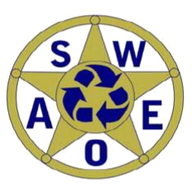

REGISTRATION FORM
Hazardous Waste Awareness Workshop
Tuesday, October 20, 2015 (10am-4pm)
Shell Island Resort
2700 North Lumina Avenue
Wrightsville Beach, NC

Name: ____________________________________________________
Title: ____________________________________________________
Employer: __________________________________________________
Address: ___________________________________________________
City, State, Zip Code: _________________________________________
Telephone: ________________________________________________
Email: _____________________________________________________
**This workshop is FREE for NCSWEOA members and anyone registered to attend the conference on October 21-23, thanks to the generous support from our sponsor, ECOFLO!
Please submit this form via email to Matt Brickey, SWEOA Treasurer, at brickemt@forsyth.cc
or by mail to: NCSWEOA
PO Box 20372
Winston-Salem, NC 27120

