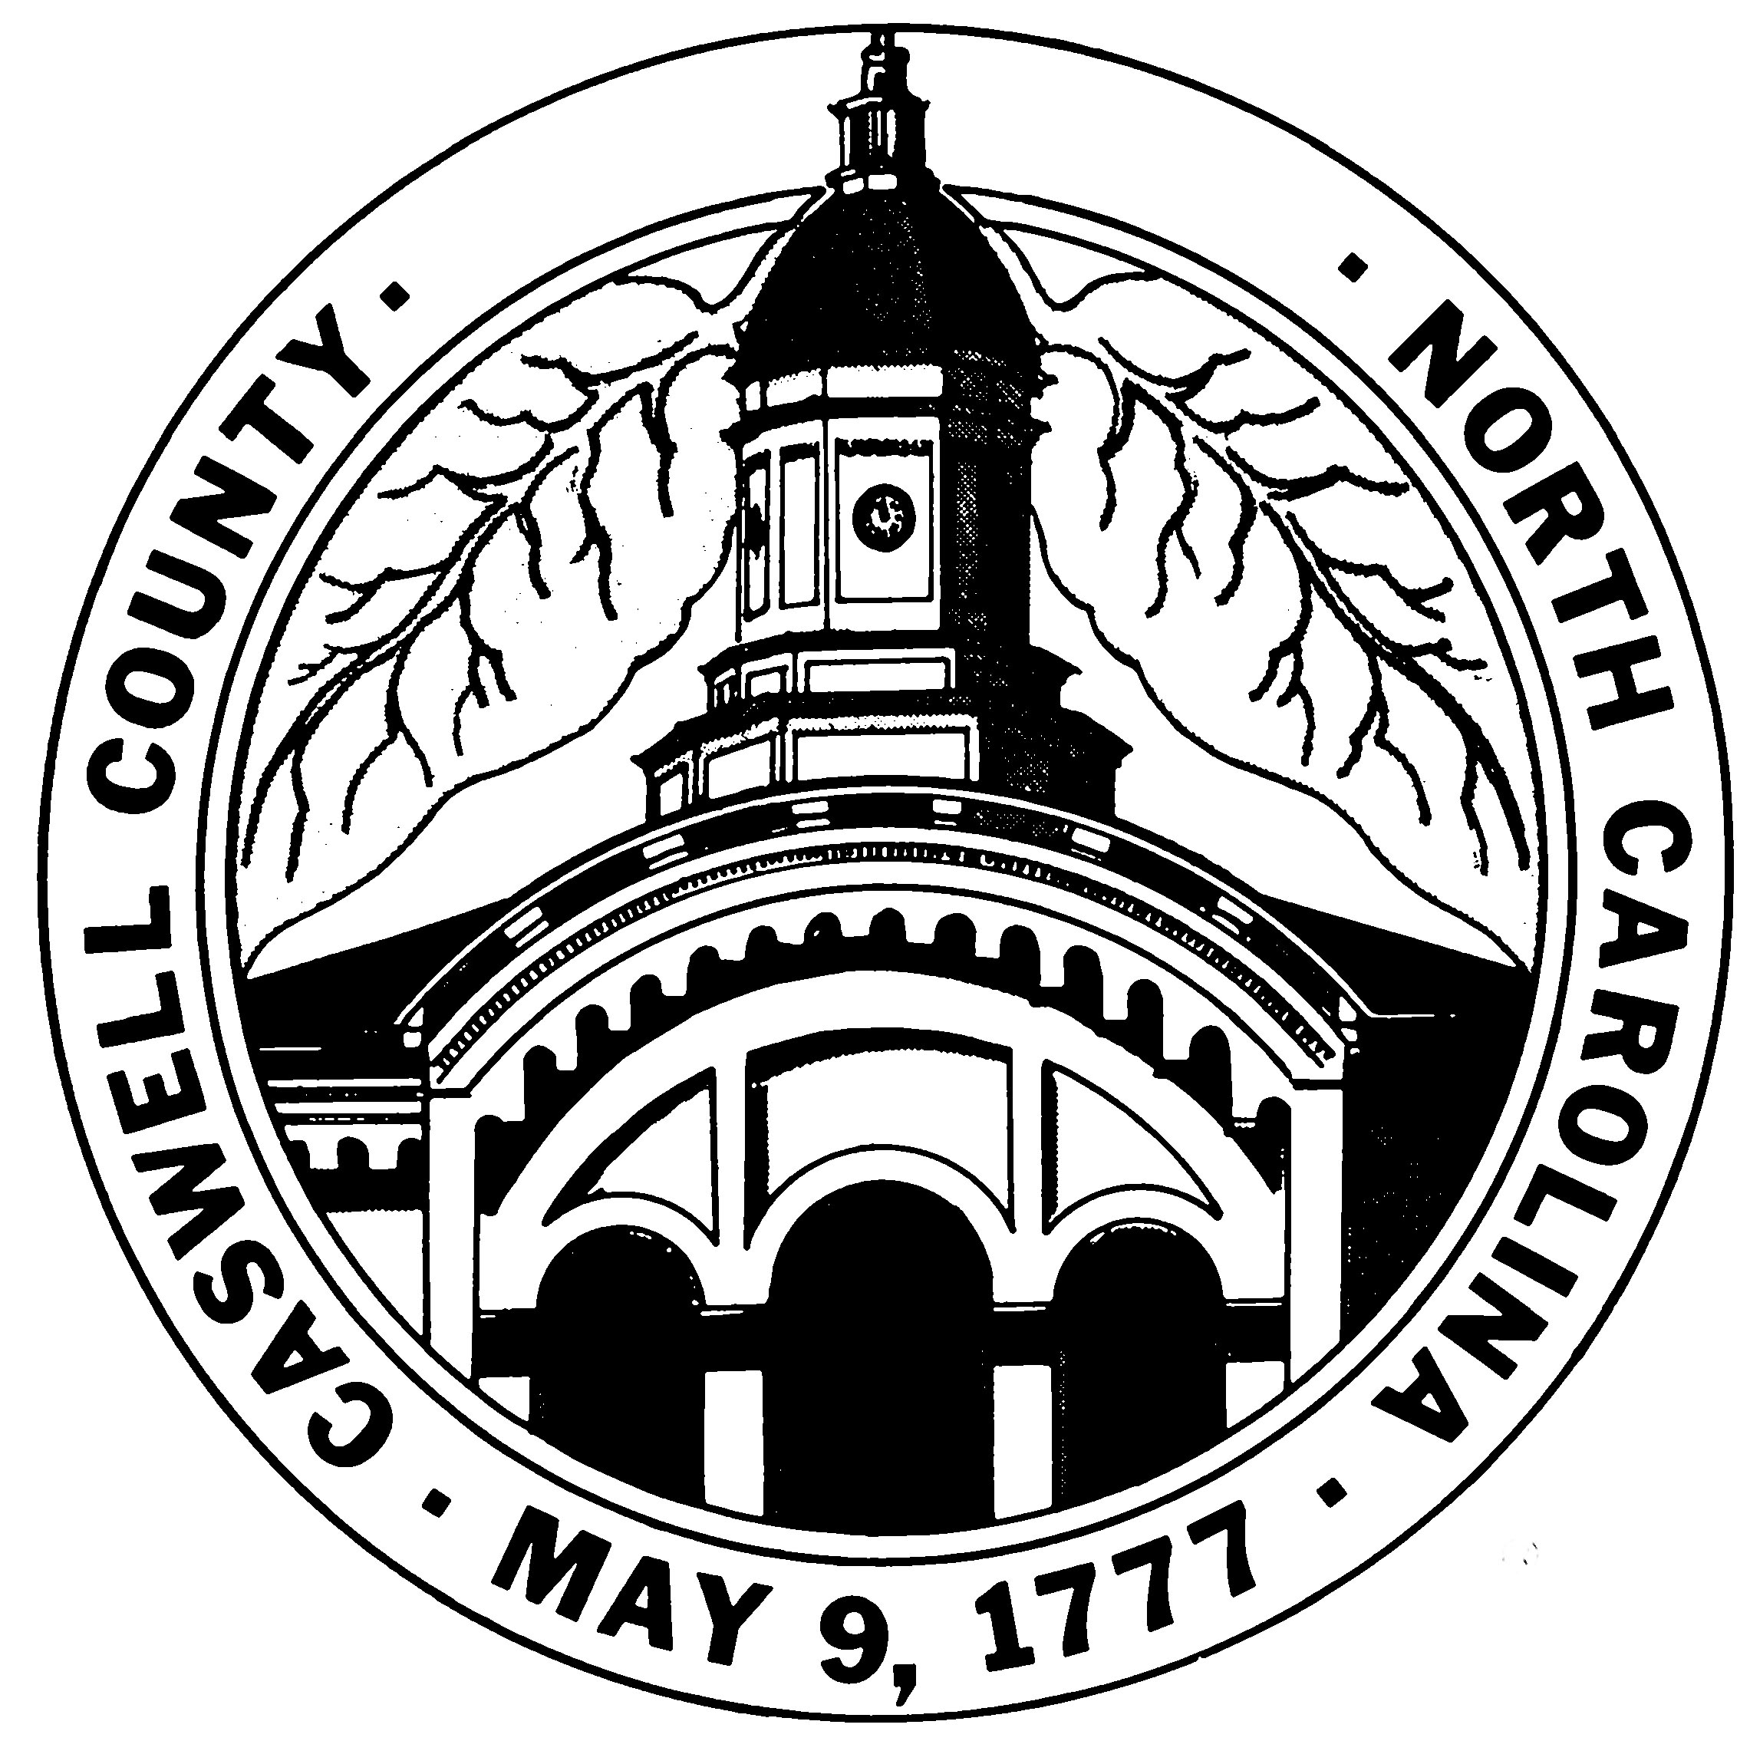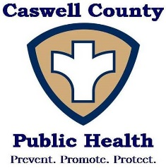
EMPLOYMENT OPPORTUNITY
ENVIRONMENTAL HEALTH SPECIALIST

JOB RESPONSIBILITIES:
- This position will work as a generalist in multiple Environmental Health Programs
- Conducts soil and site evaluations for the permitting of septic systems and private drinking water wells
- Conduct state mandated inspections and issue permits for retail food establishments, lodging establishments, public swimming pools and spas, tattoo artists, institutions and childcare facilities
- Promote and protect public health through education, inspection, surveillance and enforcement related to North Carolina Public Health Laws and Rules
- Investigation of complaints, reports of foodborne and other communicable illnesses related to establishments as mandated and evaluation of water quality standards
- Childhood lead investigations and reporting
- Other duties as assigned by the Supervisor or Director

Must have ability to work well with the public, have a good understanding of environmental health rules and regulations, have good oral and written communication skills and have basic computer skills. Must be able to operate a motor vehicle and have a valid North Carolina Driver’s License OR the ability to obtain a North Carolina Driver's License within 30 days of employment (if selected for hire).

MINIMUM EDUCATION AND EXPERIENCE: Graduation from a four-year college or university with 30 semester hours of course work in the physical or biological sciences and two (2) years of exposure in Environmental Health; or a four (4) year or Master’s degree in Environmental Health from a program which is accredited by the National Accreditation Council for Environmental Health Curricula of the National Environmental Health Association and one (1) year of experience in Environmental Health.

NECESSARY SPECIAL QUALIFICATIONS: Registered as an Environmental Health Specialist by the N.C. State Board of Environmental Health Specialist Examiners. Applicants meeting minimum education requirements without being registered may be considered for an intern position.

WORK SCHEDULE: Monday – Friday / 8:00 a.m. – 5:00 p.m.

HIRING RANGE: $45,768 with 4% increase at the end of 9-month probationary period

DEADLINE DATE: Open until filled

APPLICATION PROCESS: Complete and submit State Application PD107 along with transcript(s) to Betty Hodges at Caswell County Health Department 189 County Park Rd, Yanceyville, NC 27379

This position is subject to pre-employment screenings. Caswell County does not discriminate on the basis of race, religion, color, creed, national origin, sex, age, political affiliation, genetic information, or handicapping condition in employment or the provision of services.
.

