Samantha B. Ange, MPH, RD, LDN  Health Director | 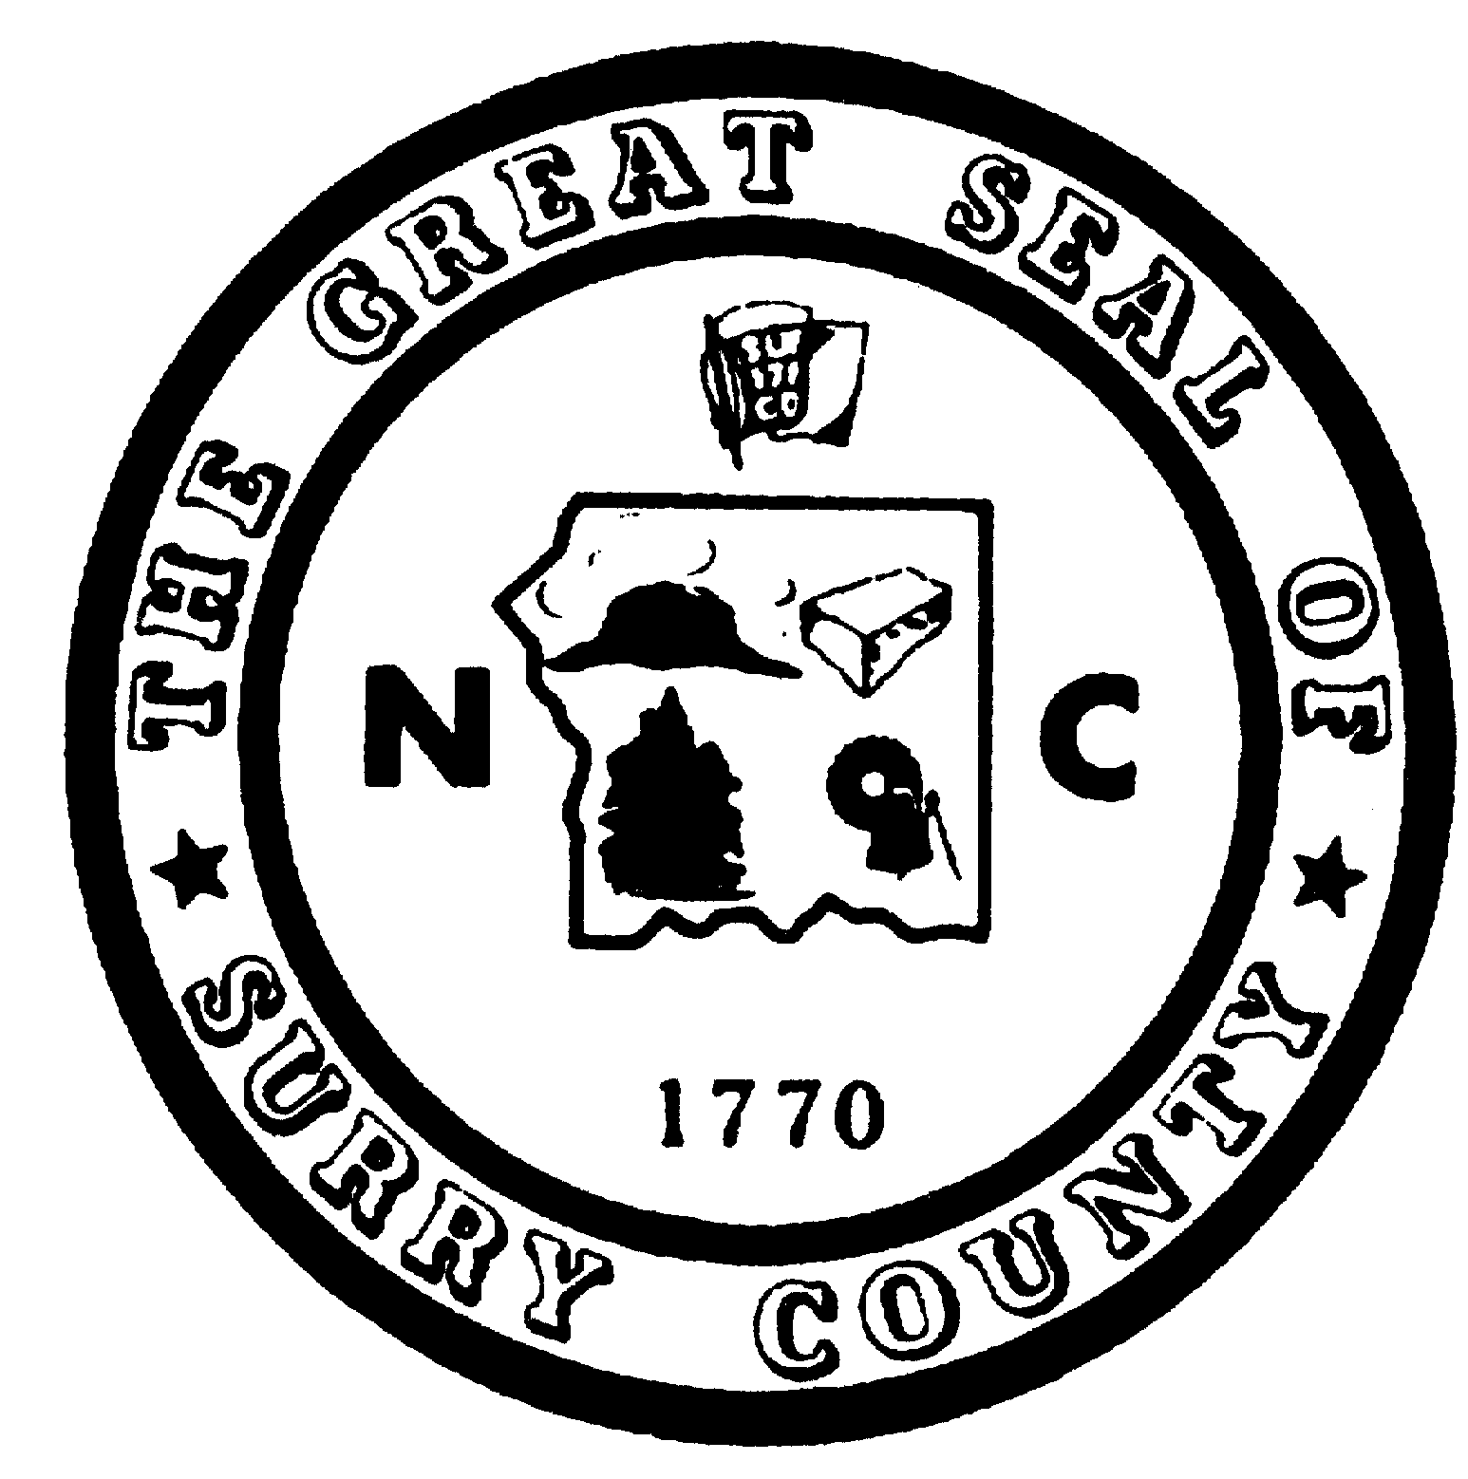 | Telephone  Dobson (336) 401-8400  Elkin (336) 366-8400
SURRY COUNTY HEALTH & NUTRITION CENTER
118 HAMBY ROAD
DOBSON, NORTH CAROLINA 27017

VACANCY ANNOUNCEMENT
SURRY COUNTY HEALTH & NUTRITION CENTER
ENVIRONMENTAL HEALTH SPECIALIST
POSITION NUMBER 545-56-704

SALARY GRADE: 68
SALARY RANGE: $37,212 - $62,196
LOCATION: Dobson, NC

Description of Work: This is professional environmental health work in the promotion of public health through education, surveillance, consultation, and enforcement of state, local, and federal environmental health laws and regulations. Employee will be working in a variety of environmental health programs, concentrating in the On-Site Wastewater Program and Wells. Other duties may include other programs and other general environmental health activities.

Minimum Education and Experience: Graduation from a four-year college or university with 30 semester hours of course work in the physical or biological sciences and two years of exposure in environmental health; or a four-year or Master’s degree in environmental health from a program which is accredited by the National Accreditation Council for Environmental Health Curricula of the National Environmental Health Association and one year of experience in environmental health. College Transcripts Required. Salary range reflects that of a fully qualified applicant; however, interns will be considered for this position.

Necessary Special Qualification: Approval for registration as a Registered Environmental Health Specialist or registration as a Registered Environmental Health Specialist by the North Carolina Board of Sanitarian Examiners prior to employment.

Application Process: To apply, applicants should contact the Employment Security Commission, 541 West Pine St., Suite 300, Mount Airy, NC 27030 or call 336-786-4169 for an application. You may also request an application by contacting Surry County Human Resources at 336-401-8221. EOE M/F Surry County does not discriminate on the basis of race, color, national origin, sex, religion, age or disability in employment or the provision of services. Surry County is a drug free workplace.

Date Posted: July 10, 2020 Closing Date: July 31, 2020

