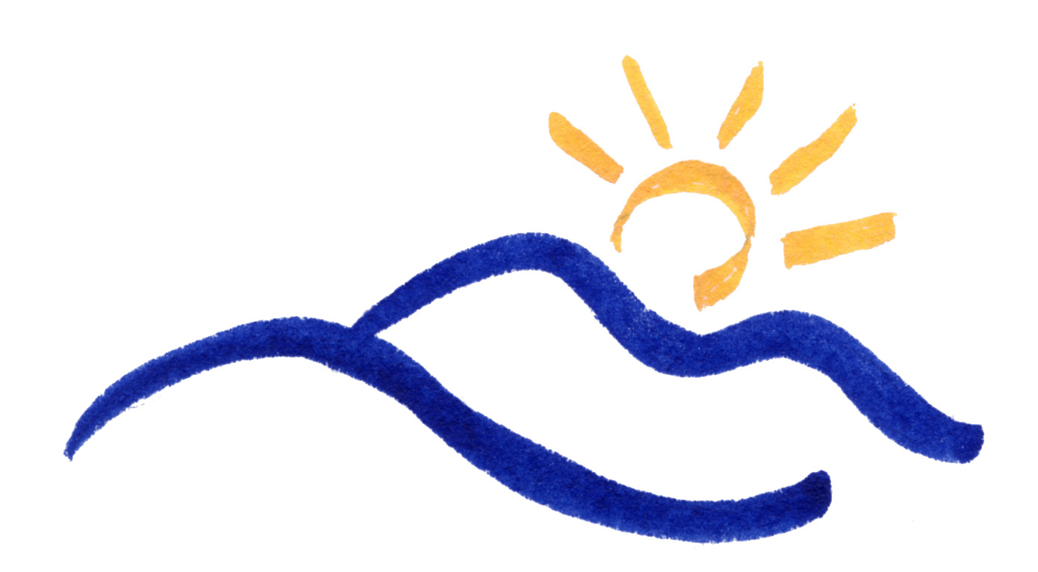
The Jackson County Department of Public Health
538 Scotts Creek Rd. Suite 100  Sylva, NC 28779
Tel: 828-586-8994  FAX: 828-586-3493
Shelley Carraway
DIRECTOR

- EMPLOYMENT OPPORTUNITY -
Please post this employment opportunity where all employees have access.

Position: | Environmental Health Program Specialist  Permanent, Full-Time
Department: | Health Department
Description of Duties & Responsibilities: | The primary purpose of the position of Environmental Health Program Specialist with the Jackson County Department of Public Health is enforcing the N.C. Environmental Health laws and regulations promulgated by the legislative body and Environmental Health Section of the North Carolina Department of Health and Human Resources. The primary focus of this position will be in the Food, Lodging, and Institutions Program. This is professional environmental health work in the promotion of public health through education, surveillance, consultation, and inspection. Work may include coordinating the work and training of Specialists, and assisting in the training of new Environmental Health Program Specialists.
Education & Experience Requirements: | Required Minimum Training: Graduation from a four-year college or university with a minimum of 30 semester hours of course work in the physical and/or biological science with two years of experience at the Environmental Health Specialist level. Required to be licensed as a Registered Sanitarian by the N.C. Board of Sanitarian Examiners.
Starting Salary: | $41, 276.54 (Grade 25).  Jackson County provides a robust offering of employee benefits including employer paid medical and dental benefits, participation in the Local Government Employees Retirement System, paid vacation, sick, and holiday leave, employee clinic and wellness program, and supplemental benefit offerings.  Full overview of benefits available at: https://www.jacksonnc.org/employment-opportunities
Application Requirements: | Submit a completed State Application (PD 107) to:  NC Works Career Center  26 Ridgeway Street, Suite 2  Sylva, NC 28779
Closing Date: | Friday, July 19, 2019.

Jackson County is an Equal Opportunity Employer.
Pre-employment drug screen and criminal background checks are required.
Jackson County participates in the federal E-Verify program.

